ASSIGNMENT 3 – CODE DOCUMENTATION

Code:
import pandas as pd
import numpy as np
from pandas import Series,DataFrame
import seaborn as sb
import matplotlib as mpl
import matplotlib.pyplot as plt
from scipy import stats

df1=pd.read_csv('FiveYearData.csv') #read the csv file
print(df1)
print(df1.duplicated().value_counts())
df2=df1[['continent','year','lifeExp']] #extract the needed columns from the dataset
print(df2)

df3=pd.pivot_table(df2,index='continent',columns='year',values='lifeExp') #create a pivot table
print(df3)

sb.heatmap(df3,annot=True).get_figure().savefig('HeatMap.png') #create a heatmap of the pivot table.

Output:
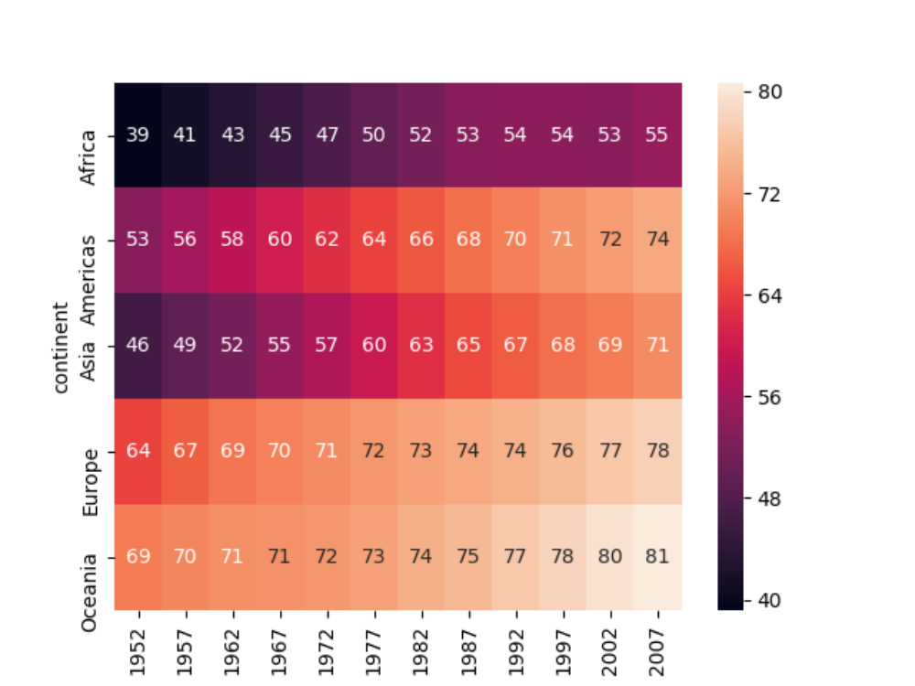

SUMMARY/EXPLANATION :-
- Read The dataset using read_csv() of pandas.
- Since the Data Set was very vast, I examined it to check if there are any duplicate values. , there were no duplicate values.
- Extracted the requires columns(continent, year and lifeExp) from the dataset into a new dataset(df2)
- Created a pivot table from that data frame (df2) with index=continent, columns=year and values=lifeExp.
- Heatmap of the pivot table dataframe was plotted using headmap() function of seaborn.
NOTE- annot-denotes annotion.
- The heatmap figure was saved as HeatMap.png.

